HARDWARE
1] There are different ways to classify motherboards, which are:

Classification Based on Assembly

Integrated Processors
Video, graphics, sound... such facilities involve components. Peripheral device slots, serial parallel ports and input output ports are other physical components or parts that are involved in the working of a computer. When such components are provided for by the motherboard, i.e. they are built into the motherboard, the motherboard is called integrated.

For example, to make a computer capable of connecting to networks, a network card is integrated onto the motherboard itself. So you do not need to buy a network card. This sort of motherboard allows for better air flow within the computer's case. Integrated motherboards cost less to make but their downside is that, if even one component on the motherboard fails, the entire board might have to be replaced. Repairing or replacing this sort of motherboard, is expensive.

Non-integrated Processors
With non-integrated motherboards, electronic components and parts are fitted individually and as needed. Input output ports, connectors, RAM etc. are fixed to the motherboard using expansion slots. So you can add one or more components as needed. This allows for greater customization and freedom in designing a PC. Gamers, for example, could fix a high-end graphics card of their choice, using the expansion slot, instead of settling for an average video card on an integrated motherboard.

But customizing a motherboard can get expensive and this is the problem with non-integrated motherboards; the initial cost is high as components need to be bought and fixed. Plus, there should be enough expansion slots to accommodate the multiple components. However, if a single component fails, then only it has to be replaced or repaired, which is a cheaper operation as opposed to replacing the entire motherboard.

Classification Based on Processor

This way of differentiating computer motherboards is based on motherboard socket types. The CPUs that are available in the current market, are compatible only with specific motherboards.

Socket A Motherboards
These motherboards are meant for AMD and Durons processors. The Socket A motherboard is also known as Socket 464 motherboard. The CPU socket in the motherboard has 462 pins and it comes in a PGA (Pin Grid Array) packaging. The bus speed of this type of motherboard is 100 to 200 MHz.

Socket 370 Motherboards
Meant for Intel Pentium III and Celeron processor, this motherboard comes for CPUs with 370 pins. It can also support VIA Cyrix III and VIA C3 processors. The bus speed for this type of motherboard is 66 to 133 MHz and it also comes in a PGA package.

Socket 378 Motherboards
This is meant for Pentium 4 processors. It also comes in a PGA package and has 478 pins. The bus speed is 100 to 200 MHz. This motherboard can also support Intel Pentium 4EE and Intel Pentium M processor. This type of motherboard is also known as Socket N motherboard.

Socket T Motherboards
Also known as LGA 775, this motherboard is meant for Intel Core 2 Duo, Intel Core 2 Quad and Intel Xeon processor. Of course, this motherboard can also support other Intel processors such as Celeron, Pentium 4, Pentium D, Celeron D and Pentium XE processor. Its specifications include 775 pins and a very high bus speed of 1600 MHz. It also comes in a PGA package.

Socket 939 Motherboards
The Socket 939 is meant mainly for the AMD family. It can support AMD processors like the Athlon 64, Athlon 64 FX, Athlon 64 X2 and Opetron. It has 939 pins and can have a bus speed from 200 to 1000 MHz. Just like the types described above, it also comes in a PGA package.

Socket AM3 Motherboards
Socket AM3 is among the most recently developed motherboards. Introduced in 2009, this motherboard is meant for AMD Phenom II and AMD Athlon II processors. It has 941 pins and a bus speed range of 200 to 3200 MHz. The packaging for Socket AM3 motherboard is PGA.

Socket H Motherboards
The Socket H or LGA 1156 is meant for Intel Core i3, Intel Core i5 and Intel Core i7processors. It has 1156 pins and comes in LGA (Large Grid Array) packaging.

Classification Based on Dimension

The dimensions of a motherboard, also known as the form factor, is another way of distinguishing between different motherboard types.

ATX Motherboards
The ATX (Advanced Technology Extended) motherboard has a length of 12 inches and a width of 7.5 inches. The I/O ports and USB ports meant for the motherboard are integrated directly in it. The bus speed in ATX motherboard is 100 MHz. This board is mainly meant for Intel processors.

Full AT Motherboards
This was the first type of motherboard, which was 12 inches wide and 11 inches long. This motherboard suffered from a lot of problems, like cumbersome access to components and overheating.

Baby AT Motherboards
With a dimension of 10 by 8.5 inches, this motherboard is meant for classic Pentium processors. The DIN keyboard connector at the top right corner of this motherboard, makes recognizing this motherboard a relatively simple task.

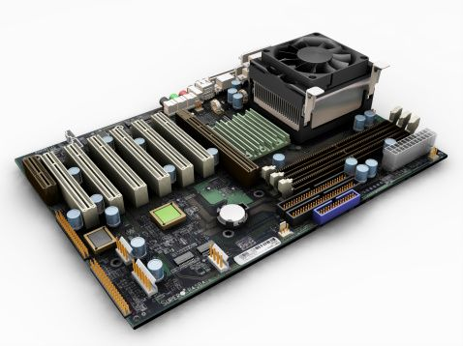

Designs of the Motherboard
Form Factors are the design of the motherboard. It is how the components of the mainboard are laid out, and especially what what type of case they fit into, and so what power supply they will be using.

ATX
ATX stands for Advanced Technology Extended. ATX was designed by Intel to allow easier expansion, and a higher degree of compatability amoung component manufacturers, while still allowing the main components of a pc intergrated into the motherboard. Its like the best of both intergrated and non intergrated motherboards. There is specific design changes that have taken place over the yearws in motherboards and since the ATX is one of the most recent, you can see that the journey of motherboards has sometimes been drastic difficulties, including where the expansion slots are in relationship to the processor. It used to be that some motherboards couldn't have new components added to them, as there was no room becuase of other parts of the board. The power supply connector for an ATX board is a 20-pin, and can support soft power off.

Micro ATX
The Micro ATX Form Factor motherboard is much smaller than ATX. The maximum motherboard size is 9.6" × 9.6". Micro ATX uses a compact design, which is favoured by pc manufacturers, who like to focus on space saving pc's and designs for their customers. Typically their custoemrs are not pc enthuasats who prefer to get their hands dirty. This is the reason and shift from a few years ago when a pc was an enourmous tower, to the slimline versions that you see now. Normally the board will have more USB peripherial slots to allow external devices to be connected. There is also an even smaller version of the Micro ATX which is called the flex atx. This is a motherboard at the size of 9.6" × 7.5". Don't expect to be able to add a pumping hot hardcore graphics card to motherboards like this.

BTX
The BTX Form Factor is the smoothest and quietiest of motherboard designs. It was designed to make sure that heat that is generated from the components is not concentrated in one place, and the motherboard can be kept cool by the primary airflow from the pc power supply.

NLX
NLX or New Low Profile Extended Form Factor, was the first effort of motherboard manufacturers at fitting slimline cases. The way they done this was to add riser exapnsion slots, which meant that the components would be parrarell against the motherboard. This style was not popular amoungst consumer of manufacturers, and quickly became replaced. Thats the reason you have probably never heard of it. However the concept may return in the future, once the issues of heat, and expansion are solved. It certainly is a good way to compact components into a small amount of space.

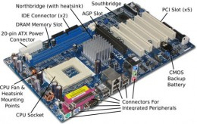

2] When doing maintenance and repair on your computer hardware, knowing which motherboard you have can save you plenty of heartache. A bit of research into the specific features of your motherboard can help you decide what to buy, and it can protect your computer from damage from hardware which is not compatible with your motherboard. The most common styles of motherboard are the AT form factor motherboard, along with its next-generation form factor cousin, ATX.

Features
- AT stands for "Advanced Technology." ATX stands for "Advanced Technology Extended." AT and ATX are form factors of motherboard. "The Complete Guide to A+ Certification" by Michael Graves defines form factor as "a term that defines the physical layout of a specific component." Form factor also denotes the type of hardware and power you can connect to your hardware component. Form factor is not just a term for motherboards; the term can be used universally for any relevant computer component.

Size and Orientation
- The ATX form factor's positioning was redesigned to offer better access to the peripheral components on the inside of the computer. Both AT and ATX motherboards have been produced in various sizes throughout the years, and the form factors fit in different computer cases depending on their size. An ATX motherboard is positioned at a 90 degree angle from the positioning of AT motherboards. As a result, you can never use an AT case with an ATX motherboard because it will not fit.

Power Use
- A notable difference between the ATX motherboard and the AT motherboard is the addition of "sleep" mode to the ATX form factor. Sleep mode is a power management mode in which some of the components are powered down to save power, but parts of the computer remain ready to boot. The sleep mode reduces the use of power when the computer is not in use, while still allowing you to more quickly revive the computer and return to where you left off. In addition, the power supply in the ATX motherboard more easily converts 5 volt current to 3.3 volts when necessary, and involves less circuitry in the process of converting the power.

Power Connectors
- The power connectors also differ between AT and ATX motherboards. AT motherboards use two 12-pin plugs to power the motherboard. An ATX motherboard uses one 20-pin plug for the power supply. When using an ATX form factor motherboard, you must use an ATX power supply. You can use the pin number to identify whether you have the correct power supply for your motherboard.

Connectors
- The outside connectors on the AT and ATX motherboards are the most visibly noticeable difference between the two form factors. The AT form factor motherboard is limited to one outside connector, a five-pin DIN connector for the keyboard. An ATX-style motherboard is built to incorporate many other connectors, including connections for network cards, video cards, sound cards and modems.
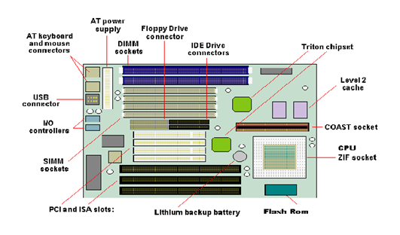

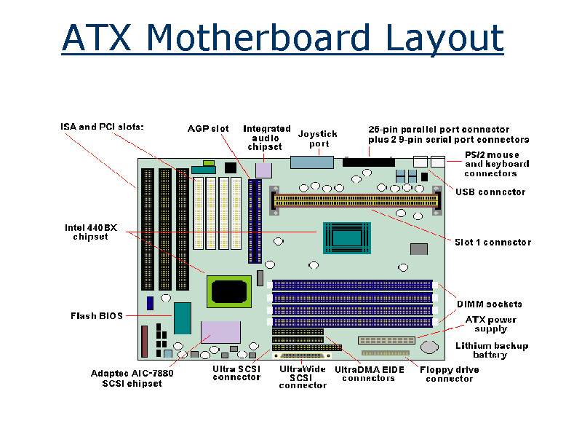

3] Connector Types
A computer cable connector is the part of a cable that plugs into a port or interface to connect a device to the motherboard or to another device. Most connectors are eithermale (containing one or more exposed pins) or female (containing holes in which the male connector can be inserted). A number of different connector types are used to connect various external devices to the computer.
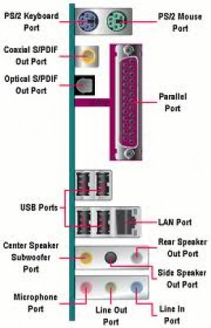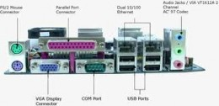

DB Connectors
This connector type is most often associated with the serial, parallel and display monitor ports. DB stands for ‘D Bucket’ connector and the full connector designation e.g. DB25 male refers to the number of pins in the connector and whether the connector is male (plug) or female (socket) type.
NB: If a DB-type port uses a female connector, the cable associated with the port will require a male connector to ‘mate’ correctly and vice versa.
The standard 15-pin VGA connector was derived from an older 9-pin design; consequently the plugs have 15 pins in a connector shell originally designed for 9. The only way to make more pins fit was to make them thinner; this also makes them more prone to bending so always take care when plugging in video leads because bent pins are hard to straighten without them breaking off. The monitor might work with a bent pin, but you will not get the correct colour output.
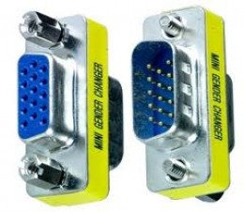
15-pin VGA connector

Full and s
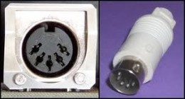
FullDIN Connector
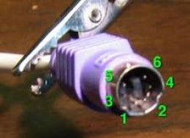
Mini DIN Connector (PS/2 Port)

The DIN connectors
Another type of connector we have is the DIN connector - DIN is an abbreviation for Deutsches Institut für Normung, or German Institute for Standardization, which is a German manufacturing industry standards group. DIN connectors are round, with pins arranged in a circular pattern. This type of connector was used widely for PC keyboards, MIDI instruments, and other specialized equipment.
We have two types of DIN, Full DIN and Mini DIN.
Full DIN or five pin DIN
The 5-pin Din connector has 5 pins that are arranged in a circular pattern. This type of connector was commonly used for older AT-style computer keyboards which are obsolete nowadays.
Mini DIN
The 6-Pin Mini Din has 6 pins as well as a keying block. This interface was first used on the IBM PS/2 personal computer. For this reason the connector is often called a PS/2 connector. This connector has become the industry standard for connecting keyboards and mice.

Audio Connectors
Most of the audio connectors on a PC are 3.5mm mono and stereo jack plugs as used on most portable domestic audio equipment.
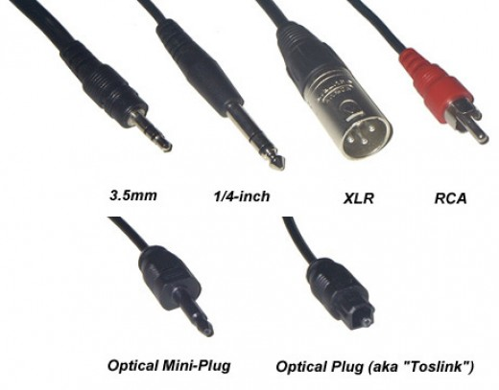

4] Wall Power Supply Voltages

If you wanted to go with a wall supply, you can get or make them in the 5-11 V range I’ve discussed so far, but the compactness advantage that makes such low voltages attractive in a portable design don’t apply with wall-powered amps. Even if you will have a hybrid power system, with a wall supply to charge an internal NiMH battery, you will probably still end up with a wall supply of at least 12 V, since you need more than the battery’s peak voltage to fully charge it. (See the section on the NiMH trickle charger for more on this topic.)

12 V

12 V is an interesting supply voltage because there are several popular good-sounding op-amps designed to run on 12 V supplies. They’re not the most popular sorts for audio, but don’t rule them out. This point is also interesting because even the least efficient op-amps common for audio will usually run happily from 12 V in this design. (Many op-amps require more than 12 V to sound good when driving the headphones directly, as in the CMoy Pocket Amp, but the buffers in this design help these chips run on lower supply voltages.)

15 V

Above, I talked about a situation where you might find yourself needing 16 V rail caps. In that case, you might look at common off-the-shelf 15 V wall supplies. I wouldn’t look to this supply level as my first choice, but it certainly can be a good choice.

5] Memory errors, data errors, brownouts, or reboots are symptoms of electrical system problems. (BY COMP_UTER15776)pixelating, frequently, cut-outs, generally when rebooting you find that it comes up with a BIOS or CMOS, or ADVANCED STARTUP OPTIONS you can achieve this normally by pressing F8. check the temperatures and voltages on the diagnostics screen just to make sure, there's a lot of useful stuff there.

Types Of Failure
Most of the time, when something goes wrong, there's at least an error message or a warning of some kind, like the infamous Blue Screen of Death, to steer us in the right direction. This piece, though, deals with failures that have no warning at all -- no BSOD, no errors, nothing. The system may hang completely, reboot spontaneously, or even shut itself off without warning.
If there's no BSOD, then the system has been -- to use a euphemism employed by another of industry colleagues -- "mugged," meaning whatever happened was outside the realm of the operating system's ability to cope with it. Such things generally fall into a few basic categories: hardware failures, electrical problems, and untrappable OS issues.
Hardware Failures are anything from a component going bad to memory failing to a device being mistakenly disconnected. A fair number of hardware failures are "trappable," meaning the OS can anticipate disasters of that variety and warn the user about what went wrong (via a BSOD). But not everything can be trapped in this fashion, simply because there's no way to anticipate it.
Electrical Problems might normally be filed under hardware failures, but I'm breaking them out as a category of their own for a few reasons. For one, electrical problems can come from outside the PC entirely (a frayed power cable, a bad socket, a dying UPS battery) or from within it (a failing system power supply, a faulty soft switch). Also, they can typically be fixed without affecting the rest of the PC or its hardware.

6] EMI shielding (Electro Magnetic Interference) - (or EMI, also called radio frequency interference or RFI when in high frequency or radio frequency) is disturbance that affects an electrical circuit due to either electromagnetic induction or electromagnetic radiation emitted from an external source.[1] The disturbance may interrupt, obstruct, or otherwise degrade or limit the effective performance of the circuit. These effects can range from a simple degradation of data to a total loss of data.[2] The source may be any object, artificial or natural, that carries rapidly changing electrical currents, such as an electrical circuit, the Sun or the Northern Lights.
RFI shielding (Radio Frequency Interference) - Radio frequency (RF) is an electromagnetic wave that oscillates between the audio and infrared in the electromagnetic spectrum. Many natural RF signals exist in nature and indeed travel throughout the universe. But typical radio frequency interference (RFI) is defined as any “unwanted” signal received by a device that prevents clear or best “wanted” signal reception. This means that RFI can affect any signal receiving system such as televisions, computers, audio and security systems, and even automatic garage door openers
ESD shielding (Electro Static Discharge) - Electrostatic Discharge, or ESD, is a single-event, rapid transfer of electrostatic charge between two objects, usually resulting when two objects at different potentials come into direct contact with each other. ESD can also occur when a high electrostatic field develops between two objects in close proximity. ESD is one of the major causes of device failures in the semiconductor industry.
7] Each class of storage device is used to store files and data but they are accessed in different ways by the computer's CPU. Here's a brief explanation of the differences.

Primary Computer Storage Devices
Primary storage refers to the computer's memory, which connects directly to the computer's CPU. The computer's memory evolved into what is now known as random access memory (RAM) which is a volatile form of storage. Volatile storage means that you totally lose data when you switch the system off.
Aside from the RAM, two other primary storage areas can be found; these are on the CPU itself; the Processor registers and the Processor cache. The Processor register is some form of small storage which resides on the CPU and can contain data which can be accessed quickly. The processor registers are measured by the amount of data the can hold, that is either, 8 bit, 32 bit or 64 bit.
Processor cache on the other hand is used by the CPU for reducing the time it takes to access the main memory. It stores data coming from the most frequently used applications of the CPU. During normal operations, the CPU checks the processor cache before checking the main memory, making the processing time faster.

Secondary Computer Storage Devices
These storage devices are external in nature and non-volatile as compared to primary storage devices. Secondary storage devices do not lose data even when they are turned off. Hence, they are the ideal back-up and data storage devices.
Examples of secondary storage devices include; CD and DVD; flash memory; floppy disks; paper and magnetic tape; RAM disks, also called SSDs; ZIP drives; and punch cards. Since secondary storage devices are not attached to the computer's CPU, it takes a longer time for the CPU to access them. Secondary storage devices need to be formatted before they can store data. Secondary storage devices are formatted based on a filesystem format data are organized into files and directories. It also includes other pertinent information about the data, which is described in what is called the metadata.

Tertiary Computer Storage Devices
This type of computer storage device is not as popular as the other two storage device types. Its main use is for storing data at a very large-scale. This includes optical jukeboxes and tape libraries. Tertiary storage devices require a database to organize the data that are stored in them, and the computer needs to go through the database to access those data.

8] Different RAM Types and its uses
Intro
The type of RAM doesn't matter nearly as much as how much of it you've got, but using plain old SDRAM memory today will slow you down. There are main types of RAM: SDRAM, DDR and Rambus DRAM.
SDRAM (Synchronous DRAM)
Almost all systems used to ship with 3.3 volt, 168-pin SDRAM DIMMs. SDRAM is not an extension of older EDO DRAM but a new type of DRAM altogether. SDRAM started out running at 66 MHz, while older fast page mode DRAM and EDO max out at 50 MHz. SDRAM is able to scale to 133 MHz (PC133) officially, and unofficially up to 180MHz or higher. As processors get faster, new generations of memory such as DDR and RDRAM are required to get proper performance.
DDR (Double Data Rate SDRAM)
DDR basically doubles the rate of data transfer of standard SDRAM by transferring data on the up and down tick of a clock cycle. DDR memory operating at 333MHz actually operates at 166MHz * 2 (aka PC333 / PC2700) or 133MHz*2 (PC266 / PC2100). DDR is a 2.5 volt technology that uses 184 pins in its DIMMs. It is incompatible with SDRAM physically, but uses a similar parallel bus, making it easier to implement than RDRAM, which is a different technology.
Rambus DRAM (RDRAM)
Despite it's higher price, Intel has given RDRAM it's blessing for the consumer market, and it will be the sole choice of memory for Intel's Pentium 4. RDRAM is a serial memory technology that arrived in three flavors, PC600, PC700, and PC800. PC800 RDRAM has double the maximum throughput of old PC100 SDRAM, but a higher latency. RDRAM designs with multiple channels, such as those in Pentium 4 motherboards, are currently at the top of the heap in memory throughput, especially when paired withPC1066 RDRAM memory.
DIMMs vs. RIMMs
DRAM comes in two major form factors: DIMMs and RIMMS.
DIMMs are 64-bit components, but if used in a motherboard with a dual-channel configuration (like with an Nvidia nForce chipset) you must pair them to get maximum performance. So far there aren't many DDR chipset that use dual-channels. Typically, if you want to add 512 MB of DIMM memory to your machine, you just pop in a 512 MB DIMM if you've got an available slot. DIMMs for SDRAM and DDR are different, and not physically compatible. SDRAM DIMMs have 168-pins and run at 3.3 volts, while DDR DIMMs have 184-pins and run at 2.5 volts.
RIMMs use only a 16-bit interface but run at higher speeds than DDR. To get maximum performance, Intel RDRAM chipsets require the use of RIMMs in pairs over a dual-channel 32-bit interface. You have to plan more when upgrading and purchasing RDRAM.
- The different pin configuration for DDR RAM Modules:
- 172-pin MicroDIMM, used for DDR SDRAM
- 184-pin DIMM, used for DDR SDRAM
- 200-pin SO-DIMM, used for DDR SDRAM and DDR2 SDRAM
- 204-pin SO-DIMM, used for DDR3 SDRAM
- 214-pin MicroDIMM, used for DDR2 SDRAM
- 240-pin DIMM, used for DDR2 SDRAM, DDR3 SDRAM and FB-DIMM DRAM

OPERATING SYSTEM
1] What is an Operating System

The operating system is the core software component of your computer. It performs many functions and is, in very basic terms, an interface between your computer and the outside world. In the section about hardware, a computer is described as consisting of several component parts including your monitor, keyboard, mouse, and other parts. The operating system provides an interface to these parts using what is referred to as "drivers". This is why sometimes when you install a new printer or other piece of hardware, your system will ask you to install more software called a driver.

2] Linux and Variants
MacOSMS-DOS
IBM OS/2 Warp
Unix and Variants
Windows CE
Windows 3.x
Windows 95
Windows 98
Windows 98 SE
Windows ME
Windows NT
Windows 2000
Windows XP
Windows Vista
Windows 7

3] A text based OS is an OS which doesn't have desktop just text. to let the OS do something, you need to type the command. Only certain applications for this OS use another view then text. A text based OS is for example MS DOS or your computers BIOS. A graphic based OS has a desktop and isn't just text on your screen. Windows 3.1 was the first graphic based OS. More recent graphic based OS are: Windows xp/vista/7

4] DIR -Lists the files in the current directory
CD, CHDIR -Changes the current working directory or displays the current directory.
COPY -Copies one file to another (if the destination file already exists, MS-DOS asks whether to replace it). (See
also XCOPY, an external command that could also copy directory trees)
REN, RENAME -Renames a file or directory
DEL, ERASE -Deletes a file. When used on a directory, deletes all files in that directory, but does not recurse or
delete the directory itself.
MD, MKDIR -Creates a new directory
RD, RMDIR -Removes an empty directory
VOL -Shows information about a volume
VERIFY -Enable or disable verification of writing for files
TYPE -Display the content of a file on the console
BREAK -Controls the handling of program interruption with Ctrl+C or Ctrl+Break.
CLS -Clears the screen.
CHCP -Displays or changes the current system code page.
CTTY -Defines the device to use for input and output.
DATE -Display and/or set the date of the system.
ECHO -Toggles whether text is displayed (ECHO ON) or not (ECHO OFF). Also displays text on the screen
(ECHO text).
LH, LOADHIGH -Loads a program into upper memory (HILOAD in DR DOS).
LOCK -Enables external programs to perform low-level disk access to a volume. (Windows 95/98/Me only)
PATH -Displays or changes the value of the PATH environment variable which controls the places
where COMMAND.COM will search for executable files.
PAUSE -Halts execution of the program and displays a message asking the user to press any key to continue.

5] Fdisk allows the user to delete and/or create partitions on the hard disk drive.
List of the menu under the fdisk:-
i. Create DOS partition or Logical DOS Drive.
ii. Set active partition.
iii. Delete partition or Logical DOS Drive.
iv. Display partition information.

6] A file system is the way in which files are named and where they are placed logically for storage and retrieval. The
DOS, Windows, OS/2, Macintosh, and UNIX-based operating systems all have file systems in which files are placed
somewhere in a hierarchical (tree) structure. A file is placed in a directory (folder in Windows) or subdirectory at the
desired place in the tree structure.

7] A physical hard drives is exactly a physical unit that can be handled. It is also referred to
as a hard drive or HDD (Hard Drive Device)
A logical drive is a subdivision of a physical hard drive and is created using a disk
partitioning program and it can only be used for storage.
A logical drive can only exist within a specialized partition known as an extended partition
and can only be created on a physical hard drive.

8] Installation Steps
i. Insert the Windows 98 CD in the CD‐ROM drive.
ii. If the Windows 98 package that requires boot from a floppy disk, insert the boot floppy
in the floppy disk drive.
a) Follow the on‐screen instructions.
b) Run FDISK and FORMAT when the installer prompts to do so
iii. Power on the virtual machine.
iv. Choose to boot from CD‐ROM, and then select the option Start Windows 98 Setup from CD‐ROM. The
setup program runs FDISK and reboots.
v. Once again, choose to boot from CD‐ROM, and then select the option Start Windows 98 Setup from
CD‐ROM. The setup program continues installing Windows 98.
vi. Follow the prompts to complete the installation.
vii. Install VMware Tools.
viii. After installation, consider the following configuration.

9] Basic Disk
Basic Disk uses a partition table to manage all partitions on the disk, and it is supported by DOS and all Windows
versions. A disk with installed OS would be default initialized to a basic one. A basic disk contains basic volumes,
such as primary partitions, extended partition, and all logical partitions are contained in extended partition.
Dynamic Disk
Dynamic Disk is supported in Windows 2000 and later operating system. Dynamic disks do not use a partition table
to track all partitions, but use a hidden database to track information about dynamic volumes or dynamic partitions
on the disk. With dynamic disks it can create volumes that span multiple disks such as spanned and striped volumes,
and can also create fault-tolerant volumes such as mirrored volumes and RAID 5 volumes. Compared to a Basic
Disk, Dynamic Disk offers greater flexibility.

20 pins for power supply cable.

6 pins (round) for keyboard.

6 pins for mouse which is next to keyboard plug in.

15 pins for the AGP slot (graphic).

40 pins ribbon cables for IDE (hard and CD/DVD).

34 pins ribbon cables for motherboard and floppy disk.

9 pins for serial port connector.

25 pins for parallel port connector.

